1. 
2. 
3. We will see how well this course is organized to help us make the maximum out of it.
4. This course is structured into sections and each section has lectures short and to the point.
5. At the end of each section, Quiz and assignment to evaluate your knowledge from that section.
6. This is complete hands-on lectures and to work on those hands-on lectures, we will do a software setup.
7. 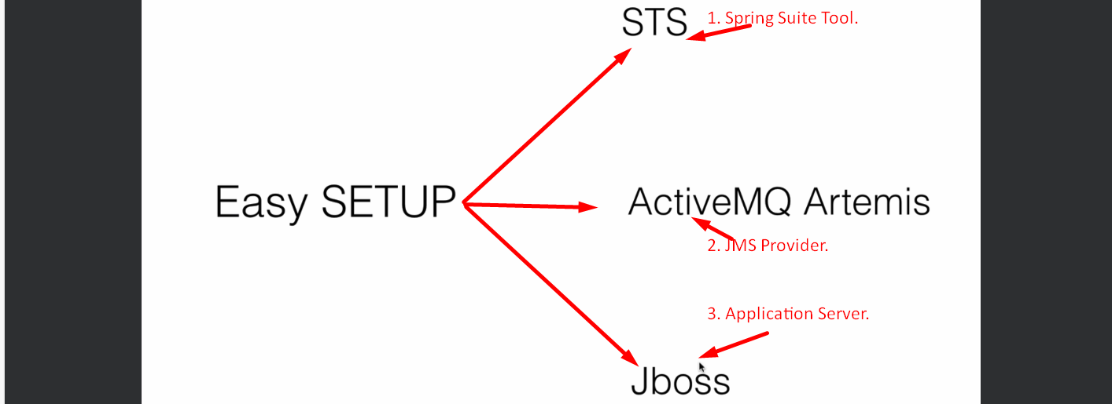
8. 
9. Make it a habit to answer the other students’ questions as great way of sharing and learning.
10. 
11. 